Ujian Akhir Praktikum - Semester Ganjil 2020/2021
Practicum Final Exam –Odd Semester Year 2020/2021
Matakuliah  Subject |  |  | ISYS6169 – Database Systems |  |  | 
Kelas  Class | : | BA08 |  | Tanggal Mulai  Start Date | : 07 January 2020
Kelas  Class | : |  |  | Waktu Mulai  Start Time | : 11:20
Dosen  Lecturer | : | D5385 - Fifilia, S.Kom., M.MSI |  | Tanggal Selesai  End Date | : 07 January 2020
Dosen  Lecturer | : |  |  | Waktu Selesai  End Time | : 13:20

PERATURAN UJIAN:
Exam Regulations:
- Mahasiswa tidak diperbolehkan berdiskusi dan/atau bekerja sama dengan peserta ujian lainnya
Student is not allowed to discuss and/or work together with other exam participants
- Mahasiswa tidak diperbolehkan untuk membuka dan menyalin dari BUKU atau CATATAN, VIDEO dari pengajar (recording kelas, VBL, Youtube, dsb) dan REFERENSI lainnya
Student isn't allowed to open and copy from any resources such as notes, videos (class recording, VBL, Youtube, etc) and other references
- Mahasiswa tidak diperbolehkan membuka dan menyalin jawaban dari internet (google, stackoverflow, dsb)
Student isn't allowed to open and copy answer from the internet (google, stackoverflow, etc)
- Asisten BERHAK memberi nilai 0 (NOL) bagi peserta ujian yang melakukan segala bentuk kecurangan
Assistant is able to give 0 (ZERO) score for exam participant who does any cheating actions
- Kumpulkan jawaban tepat pada waktunya, apabila terlambat mengumpulkan maka jawaban tidak akan dikoreksi dan nilai mahasiswa adalah 0
Submit the answer on time, if not, then the answer will not be checked, and the students will receive 0 (ZERO)
- Bila Anda tidak membaca peraturan ini, maka Anda dianggap telah membaca dan menyetujuinya
If you have missed to read these regulations, so you are considered to have read and agreed on it



SOFTWARE YANG DIGUNAKAN:
Software will be used:
- SQL Server Management Studio 18.5.1
- SQL Server Developer 2019
- Microsoft Office 365

FILE YANG DIKUMPULKAN:
File must be collected:
- SQL

PERHATIAN!
Attention!
- Bagi yang mengerjakan tidak sesuai dengan soal, maka akan diberikan nilai NOL (0)
For those who do not work in accordance with the exam case will be marked as ZERO (0)
- Bagi yang mengerjakan tidak sesuai dengan software dan versi yang telah ditetapkan, maka akan tetap dikoreksi dengan software dan versi yang telah ditetapkan
For those who do not work in accordance with the software and specific version will be corrected by the predefined software and version
- Kompres semua jawaban yang akan diunggah. Pastikan format pengumpulan nama file dan ekstensi sesuai dengan format berikut: [NIM]-[NAMA].zip
Compress all file that will be uploaded. Make sure the format for collecting file name and extension according to the following format: [NIM]-[NAME].zip

Tabel Relasional
Relational Table

Cooking Simulator

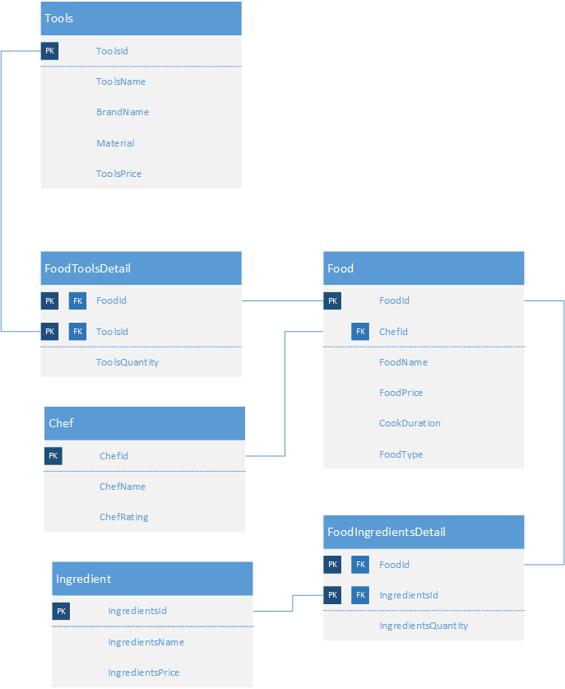

Soal
Case

- Display Food Name (obtained from FoodName in uppercase format) and Price (obtained by adding “IDR “ in front of FoodPrice) for every food that contains “Fried” in its name.
(upper, cast)

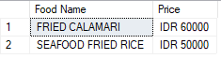

- Display Chef (obtained from ChefName), Chef Rating (obtained from ChefRating ended with “ stars”), and FoodName for every chef name that contains at least 2 words.
(join, cast, charindex)
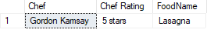

- Display FoodName and Spending (obtained from total of quantity multiplied by price) for every food which price is lesser than 100000, cook duration between 30 and 60, and Spending between 50000 and 150000.
(sum, join, group by, having, between)
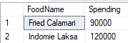

- Display Chef Rating (obtained by adding ‘Rating ’ in front of ChefRating), Total Food (obtained from the total number of food), and Total Food Price (obtained from sum of FoodPrice) for every chef which rating is 5. Then, combine it with Chef Rating (obtained by adding ‘Rating ’ in front of ChefRating), Total Food (obtained from the total number of food), and Total Food Price (obtained from sum of FoodPrice) for every chef which rating is 3.
(count, sum, group by, union)
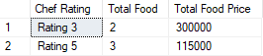

- Display Ingredient Name (obtained from unique value of IngredientsName) for every food which price between 50000 and 100000 and contains those ingredients.
(distinct, in, subquery)
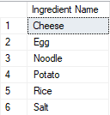

- Select Food Name (obtained by removing the first word of FoodName), Price (obtained from FoodPrice) for every food that have at least 2 words in its original name and FoodPrice greater than average price of all ‘Beverage’ FoodType.
(substring, charindex, len, alias subquery, average, like)
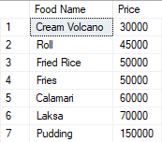
- Create a view named “Show Food” to display Chef Name (obtained from first word of ChefName), Chef Rating (obtained from ChefRating), Food (obtained from FoodName), Duration (obtained from CookDuration), and Price (obtained by adding “IDR ” in front of FoodPrice).
(create view, left, charindex, cast)
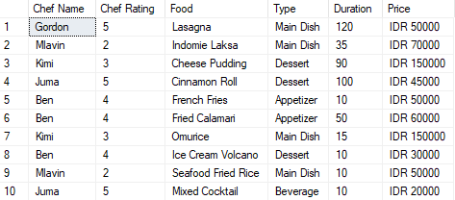

- Create a view named “Chef Food Price” to display ChefName and Total Food Price (obtained by adding up FoodPrice and put “Rp. ” in front of Total Food Price and “,00” in the end of Total Food Price) for every Total Food Price greater than 100000.
(create view, sum, having)
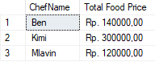

- Add “CheffGender” as a new column on Chef table with char data type and 6 as the length and give “N/A” as CheffGender default value. And then add a constraint for Chef table to validate ChefGender value must be between “Male” or “Female” or “N/A” only.
(alter table, add, add constraint)
Before:
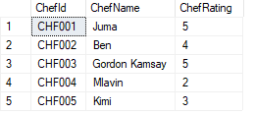
After:
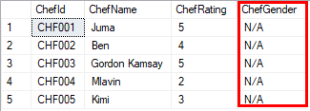

- Increase ChefRating on Chef table by 1 point for every chef that put “Garlic” as their food’s ingredient and the food price is greater than 10000.
(update, in)
Before:
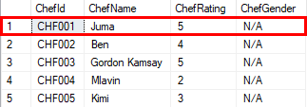
After:
